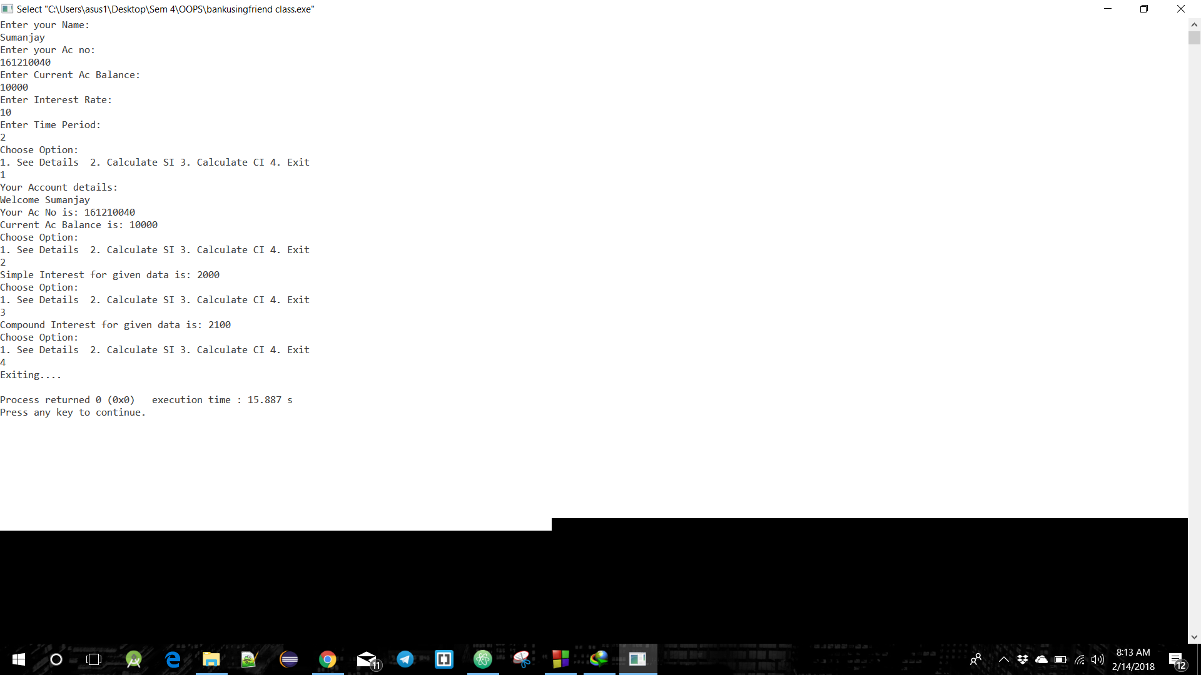

**Interest Calculation Output**

(Implementation of Friend Class)

A screenshot of a cell phone

Description generated with very high confidence